**Gyrator:**

A gyrator is two port ferrite device which exhibits a phase shift of 180 degree when signal propagates from port-

1 to port-2 whereas there is no phase change when signal propagates from port-2.

**Construction:**

**Various components used in Gyrator**

1. **﻿**Circular waveguide operating in mode TE11.
2. Transition
3. 900 Twister
4. Ferrite Rod

When signal enters at port-1 it passes through the circular waveguide and 90° phase shift and is entered in the transition. The role of the transition is to convert mode of circular waveguide to the equivalent rectangular waveguide mode.

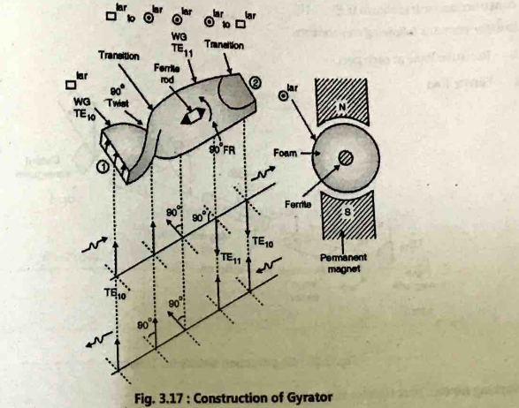

﻿

Operation:

* When electromagnetic signal enters at port 1, this signal passes through the 90° degree twister resulting in the phase shift of 90°. Thus plane of wave polarization rotated by 90° in anticlockwise direction.
* This wave now passes through the ferrite rod. Length of the rod is designed to give phase shift of 90° in anticlockwise . When wave come out from port-2 total change in the phase is of 180°.
* Now when signal enters at port-2 instead at port-1, it passes through ferrite rod where phase shift of the 90°occurs in anticlockwise direction.
* When this signal passes through the twister. It undergoes phase shift of 90°in clockwise direction. This compensates for the phase change of 90°in anti-clockwise direction.
* Thus signal entered from port-2 do not have any phase change. Thus gyrator gives phase shift of 180° when signal travels from port-1 to port-2.

Q. Explain Working of Circulator with neat sketch.Explain in brief Microwave Circulators.

**Circulator:**

* A microwave circulator is a multiport waveguide junction in which wave can flow from nth port to (n+1) port in one direction i.e. there is no power flow in reverse direction i.e. from (n + 1) port to n port.
* The four port circulator is shown in Figure. One type of four port microwave circulator is a combination of two directional coupler and rectangular waveguide with two non-reciprocal phase shifter.

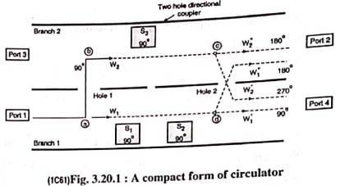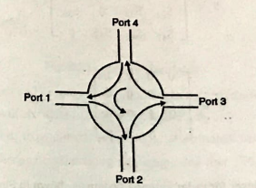

**Working principle of Circulator:**

* Consider a signal applied at port 1. It appears at point a where there is hole 1 coupling. This signal splits into two components W1, and W2. The components W1, travels towards right in branch 1, while travelling it passes through phase shifters S1 and S2.
* The phase shifter S1 adds a phase shift to 90° but S2 add nothing. The total phase of W1, is changed by 90°.This signal appears at point d where there is hole 2 coupling, here signal further split into two components W’1 and W”1.
* The component W’1 travels right towards port 4 with a phase of 90°.The component W”1, passes through hole where its phase is changed by 90° resulting in a 180° phase. This component travels towards port 2.
* The component W2 enters through hole 1 into branch 2. While passing through hole its angle is changed by 90°, and it starts travelling right.
* It passes through phase shifter S3, where its angle is further changed by 90°.
* Thus a signal appearing at point C has a phase of 180°. The signal at point C is divided into two parts W’2 and W”2
* The component W”2 travels towards port 2 where it is added with W"1. Since both are in phase they add, resulting in maximum signal out of port 2.
* The component W’2 when passes through hole 2 its angle is changed by 90° making total phase of 270°. This component travels towards port 4. Two components travelling towards port 4 are W’2, and W’1, are having a phase difference of 180° between them, resulting in total cancellation at port 4.
* Thus signal applied to port 1 travels only to port 2.

The sequence of power flow is 1 -> 2 -> 3 -> 4 -> 1. The perfectly matched, lossless and non-reciprocal four port circulator has s matrix as,

S =

This can be simplified as

S =

It is used extensively in making basic devices for communication and radar systems. Some of the

applications are

(i) as an isolator (iii) as a phase shifter

(ii) as a duplexer (iv) as a multiplexer

**Hybrid ring / Rat-Race junction:**

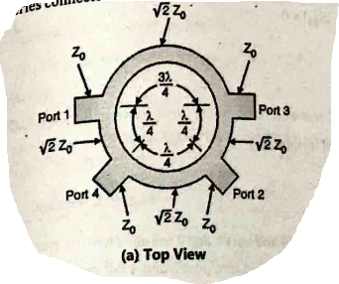

Hybrid ring is the types of Hybrid junction which is used to divide the power. Following are the two types used for power division which are shown in Figure

(1) Shunt connected TEM type

(2) Series connected waveguide type.

﻿

**Design:**

It consists of transmission line ring having mean circumference of 32/2 and characteristic impedance equal to √2*Zo

Zo→ characteristic impedance of the connecting lines.

**Properties of Hybrid Ring:**

(1) Port 1 and 2 are decoupled as are port 3 and 4.

(2) Signal entering either at part 1 or 2 splits equally between port 3 and 4.

(3) Signal input at port 3 or 4 splits equally between port 1 and 2.

﻿

**Working of Hybrid Ring:**

(1) Consider I/P signal is applied at port 1.

(2) The signal splits and propagates in both directions

(3) The standing wave pattern is generated along the transmission line Ring.

(4) A voltage null exists at port 2 since the difference in path lengths causes the two waves to arrive at that port 180° out-of-phase.

(5) When port 3 and 4 are match terminated, the null is unaffected by their presence. Because the phase shift and loss experienced by the wave as it passes port 3 is identical to that of the wave propagating past port 4.

(6) Identical voltage maxima exists at port 3 and 4 and therefore equal power is available at each port. With characteristic impedance of ring equal to √2*Zo port 1 is matched when ports 3 and 4 are match terminated.

**S-Parameters for Hybrid Ring:**

* Since it has 4 ports S-Matrix will be 4x4

[S] =

* Since port 1, 2, 3 and 4 are match terminated

|l= ||= |= ||=0

* Due to symmetry of S-matrix

|= ||

|= ||

* But since port 1 and 2 as well as port 3 and 4 are matched terminated

|= ||= 0

|= ||= 0

* port 1 and 3 are at distance of 3 λ /4 and port 1 and 2 are at λ/4.

When I/P is applied to port 1, equal amount of the power gets divided into port 3 and 4 but exactly 180° out of phase.

|= ||

|= j/√2

|| = j/√2

﻿

* Due to symmetry

|= ||

|= ||

* Thus from all above, [S] matrix for Hybrid ring will become

[S] =

* Now it is left 1 to find S23 and S24

According to [S] matrix symmetry

|= ||

|= ||

When the I/P is at port '2', and since 2 and 3 as well as 2 and 4 are at distance of /4, equal amount of the power gets divided but exactly 180° out of phase

|= ||

|= ||

* The complete S-matrix for Hybrid ring is

[S] =

**Advantages of Hybrid Ring:**

(1) Good amount of isolation is obtained between port 3 and 4

(2) Port 1 and 2 are always decoupled.

(3) I/P power splits equally between ports 3 and 4

**Limitations:**

The isolation between ports 1 and 2 and between 3 and 4 is a result of the 1/2 difference in path length for the two waves in the Ring. This condition only exists at the design frequency and therefore useful bandwidth of the hybrid ring is limited.

**Explain coupling mechanism in waveguide.**

**﻿**In order to excite a particular mode, the cavity must be property coupled to an external source. Following four techniques are used to couple the cavity either to external source or to load. They are shown in Figure.

(a) Loop coupling

(b) Probe coupling

(c) Aperture coupling for TMnmp cavity

(d) Aperture coupling for TMmnp cavity

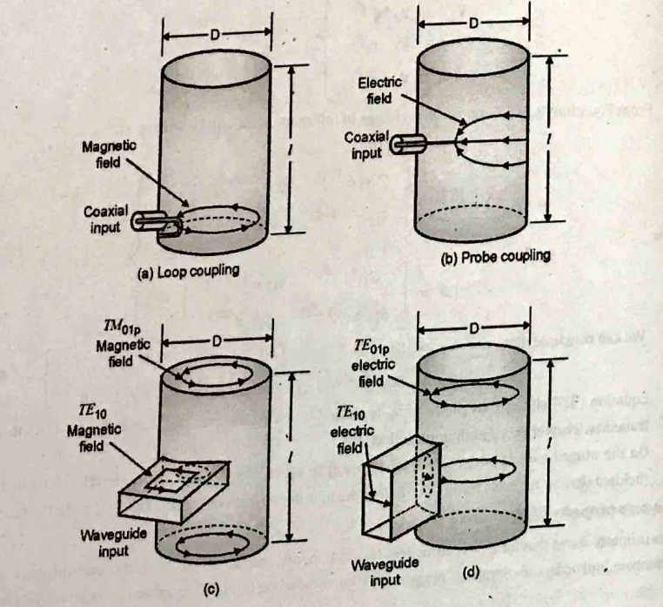

**Terminations**

**Matched Loads-Terminations**

* To get maximum power at desired frequency, two different following arrangements are done in waveguide. Theyare known as Terminations.

1. Matched load.

2. Variable short circuit that produces an adjustable reactive load.

* The main application of these terminator is for impedance matching during various high frequency parameter measurements.

**Matched Load**

* The matched load provides terminations that absorbs all incident power and hence is equivalent to terminating line in its characteristic impedance
* Due to this matched load, maximum power is transferred and ideally there is no reflected wave. Thus standing wave pattern is not form when load is matched.
* There are mainly following two types of matched load which are famous:

1. Lossy wedge

2. Tapered resistive card.

* In case of lossy wedge tapered wedge or slab of lossy material is inserted into the guide. Since material is lossy, the incident wave is absorbed by the material i.e. by this matched load. There are no reflections.
* The tapered resistive card also absorbs power due to its tapered nature and thus impedance matching is achieved.

**Magic TEE/ E-H plane TEE/hydrid tee**

* Hybrid Tee or Magic Tee is a combination of E and H Tee. E-Tee and H-Tee are coupled in perpendicular manner to each other to form Magic Tee.
* It has four port. Collinear arm forms PORT-1 and PORT-2. Out of two perpendicular arm, one is E-ARM and another is H-ARM.
* This four port hybrid Tee or magic tee consists of all properties of E and H plane Tee. Therefore, all port of magic tee can be utilized for matching.

﻿ 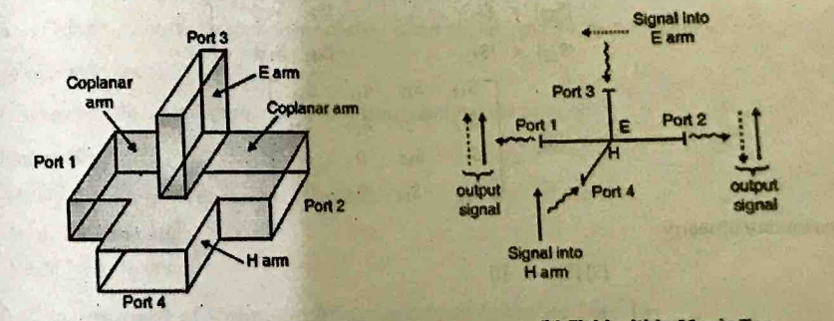

**Functioning of the MAGIC TEE:**

1. When I/P is applied at collinear ARM: When two signal having same amplitude and same phase are applied at PORT-1 and PORT-2, there is no signal at E-ARM. Summation of signal is obtained at H-ARM.
2. When I/P is applied at E-ARM, power is distributed equally at PORT-1 and PORT-2. Amplitude of the signal at both PORT is same but they are out of phase. Also there is no power coupled at H-ARM.
3. When I/P is applied at H-ARM: When I/P to the H-ARM, signal available at PORT-1 and PORT-2 will be same in

amplitude and phase. There is no signal at E-ARM.

**The S-matrix for Hybrid Tee can be obtained as below:**

* [S] is 4 x 4 matrix since there are 4 ports

[S] =

* When I/P is applied at PORT-3, It is divided equally at PORT-1 and PORT-2. but they are out of phase. Also there is no power coupled at PORT-4.

|= ||

|= ||

|= 0

* When I/P is applied at PORT-4, It is divided equally at PORT-1 and PORT-2 in phase. Also there is no power coupled at PORT-3.

|= ||

|= 0

* If ports (3) and (4) are perfectly matched to the junction

|= |= 0

* From the symmetry property

|= || |= ||

|= || |= ||

|= || |= ||

[S] =

* From unitary property

[S] [S]* = [I]

|2+||2+|2+||2= 1 ……………… (1)

|2+||2+|2+||2= 1 ……………… (2)

|2+||2= 1 ……………… (3)

|2+||2= 1 ……………… (4)

Substracting (1) and (2)

|2 -||2 = 0

|||

………………… (5)

………………… (6)

Substitute (5) and (6) in (1)

|2+||2+ +  = 1

|2+||2 = 0

3rd row 1ST col

|*|+||* = 0

|= ||

2|

|= 0

Which is valid if |= || = 0

Thus, |= || =|| = 0

[S] =

﻿

**Advantage of Magic Tee:**

Power at any port does not depends on the port termination at other port.

**Applications of Magic Tee:**

1. Mainly used to measure unknown impedance.

2. Magic Tee-as a mixer.

3. Magic Tee as Isolator.